Magic Invitational Report: Gary Wise
Gary Wise
When your name is attached to one of the most dubious records in Magic history, you're bound to feel a little pressure not to repeat it. Two Invitationals ago at Kuala Lumpur, I had one of the greatest weeks of my life, but the cost of my good times was a horrendous 2-13 record in the tournament. Among players who have actually shown up, no one has shown themselves to be capable of being nearly as bad as me.
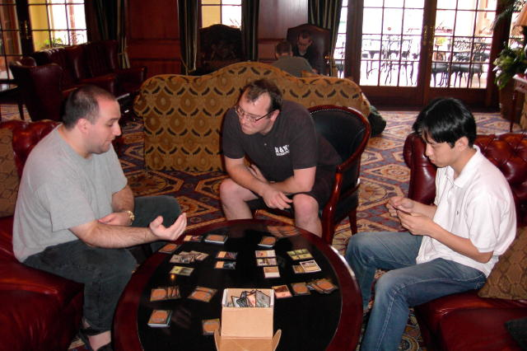
Wise and Fujita have some fun
With that in mind, I've maintained the same outlook on the Invitational to this day that I carried into that tournament: The Invitational is the one time during the year I get to play the world's best for pure entertainment value. No money, no pro points, no threshold to reach, just fun, casual Magic, so I treat it as such. The week leading up to the Invitational, Ben Ronaldson repeatedly asked if I wanted to playtest. I always replied that we should be playing Extended or drafting Odyssey.
For the third Invitational in a row, Kai Budde and I were both invited to the tournament and took advantage by going four days early in order to get a better look at the location in question. This time was no disappointment, as Cape Town is a beautiful, modern and extremely affordable city. With the Rand's value at one ninth that of the U.S. Dollar, everything felt unbelievably cheap, and Kai and I took advantage.
Our first few days in town were made very easy by the generous nature of the Magic community of South Africa. Peter Coode, the regional manager, made sure we knew where and what everything was, including taking us out to eat Ostrich, organizing lifts and the like. Garth Murray, the local level 3 judge and Andrew Mitchell, recognized as the country's best player, took us out our first night to see a little of Cape Town. Andrew Monteith, an occasional pro, took us to a Prerelease the next day where Kai and I became acquainted with the local players while coming second and third respectively, and four Grand Prix staff members, Dennis, Natanya, Emily and Mark took us to a bar where we were taught how to play African drums. All in all, the four-day precursor was a great time, as always.
The first Invitationalist we saw was Scott Richards who, along with a friend who'd tagged along for the trip, James White, came to the Prerelease and the African bar with us. Once at the bar, James, a PT aspirant, set himself up to be the chairman of entertainment for the group and didn't disappoint. By this time, Dan Clegg and Brian Kibler had joined us, while Chris Benafel stayed at the hotel a little hung over.
Once the other Invitationalists arrived, we got down to gaming. Whether it was Magic, Backgammon or a Japanese version of Chess, the Pro Tour's finest could be seen throughout the casino's lobby, gaming. There were a few problems getting Tsuyoshi Fujita to the event, about which I felt a little badly as I'd talked him into making the trip, but in the end things worked themselves out. The night before the tournament, at the end of a day of wine tasting, cheetah petting and futile attempts to hunt down some shark, Fujita won over the rest of the players with a dance at a traditional African restaurant, where he outmaneuvered the waitress who volunteered him, pulling him onto the floor.
The tournament itself was a lot of fun to play, even if it went a little slowly. For the Duplicate Sealed portion, I think I did a solid job of deck building, going with a blue-white design that took me to a 2-1 record. Especially exciting was a win over the man himself, Jon Finkel, in the first round. It was my first in three tries at the Invitational, and would set a pattern for the rest of the tournament, as I'd eventually beat the two other Deadguys, Price and Pikula, against whom I was also 0-2 going into Cape Town.
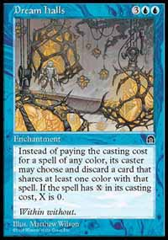
The second format of the day was 5-Color, for which I'd decided to play Zvi Mowshowitz's Turbo Zvi deck. He'd done a little work on it before illness forced him out of the Invitational and the frame he'd built was tightened by his replacement Scott Johns, so it seemed like a natural fit to play it. All in all, I think the deck is pretty solid, if not a little quirky, with Dream Halls being broken in the format. 5-Color probably wasn't the most practical format, in that I had to borrow cards from five people I didn't know before the weekend, but it was a lot of fun to play. I went 2-1 in 5-C, leaving me in third place after Day 1.
Day 2 started with what was undoubtedly the Magic highlight of the weekend for me: Rotisserie Draft. I'd never actually participated in the format before and didn't really know what to expect, but found myself really enjoying the format. Being the top-ranked player at the table, I got to choose my seat, and I took seat 8, as most of the top cards in Odyssey are comparable in power.
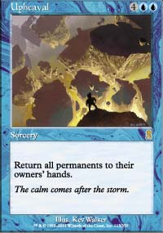
I think the draft went pretty well for me. I made one bad pick early, taking Master Apothecary way too early, but made up for it later with a seventh pick Upheaval, which is quickly becoming my favorite Limited card in the set. I ended up with a very solid blue-white deck that Mike Pustilnik deemed the best at the table, but some poor play on my part left me with just a 1-2 record for the format, losing to Mikey and Kamiel Cornelissen in the second and third rounds.
The bad streak continued into the Standard portion, where I may have been the most unprepared competitor in the tournament. I had a strong deck in my email inbox from John Ormerod, but hadn't had time to access it the night before for building, as we finished after midnight. As a result, I had to rush up to my room between rounds, and with James's help, piece together a deck. The end result was a pretty poor blue-black-green deck that I'd recommend no one play ever again. I lost two matches in a row, including a savage drubbing at the hands of Tsuyoshi, before having the good fortune to play Antoine Ruel, who helped me salvage a 1-2 record in the format. After seven rounds I was in first place. After eleven rounds I couldn't make top two.
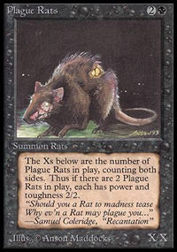
Day 3 was the auction, and while I felt the Chimera deck was the strongest, it seemed it would be overbid upon, so my goal was to get the land deck, feeling I could go as low as four cards, as it would never get mana screwed. I came away with the deck at what I still feel was a very good price of 5 cards, 15 life and prepared to play my final rounds as Mikey P claimed the Rat deck I "designed". After the tournament, I got all of the competitors to sign the deck box I won for having my deck selected, which I hope to be able to auction off for charity.
The Auction went well for me, with my loss to Scott Richards being balanced by a second turn kill against Tom Van de Logt (Crop Rotation for Dust Bowl, same thing), and in the end, I went 2-1, with a third game, fifteenth round win over Chris Pikula finishing me at 8-7, in the top half of the standings for the second straight year. The rest of the day was spent gunslinging with the help of some of Olivier Ruel's friends, a nice dinner on WotC, and finally, blissful sleep.
I want to thank everyone who made the trip a good one, congratulate Ben Seck for his win at the Grand Prix, send a special nod out to Tsuyoshi Fujita for our lunch time conversations, Scott Johns for helping me with my 5-Color deck, Kai Budde for being a great travel companion, Mark Rosewater and Carl Crook for their organizational efforts and the rest of the Invitationalists for a very good time. Most importantly though, thanks to those of you who decided I'd merited your votes, as without you, I never would have had this great experience. I'm gratified that you feel my efforts made me a worthwhile. Thank you.

